New Toyota Hilux 2026: Price, Specifications, Features & Full Review
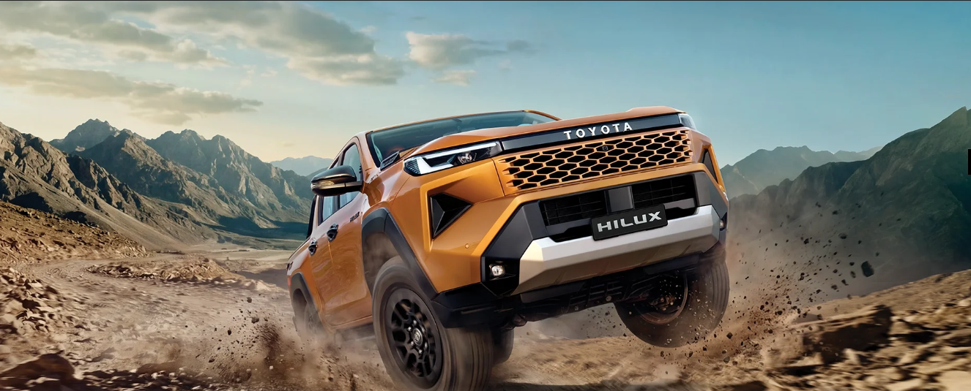
Toyota has finally pulled the wraps off the all-new Hilux for the Indian market, and if the brochure is anything to go by, this is not just another lifestyle pickup truck. It is a statement. Wearing a design language Toyota calls "Cyber Sumo architecture," the new Hilux blends old-school ruggedness with a genuinely modern cabin, a torque-rich 2.8-litre diesel engine, and a 4x4 system built for serious off-roading. With prices ranging from ₹31.99 lakh to ₹36.69 lakh (ex-showroom), the Hilux positions itself as a premium lifestyle pickup rather than a budget workhorse, and it is aimed squarely at buyers who want a vehicle that can handle a muddy trail on Saturday and a boardroom parking lot on Monday.
In this detailed review on BikeCarHub, we break down everything you need to know about the new Toyota Hilux — its design, engine, interior, safety kit, variants, on-road price, colour options, accessories, and how it compares across its own line-up. Whether you are a die-hard off-roader, a fleet buyer, or someone simply curious about Toyota's newest India launch, this guide should answer nearly every question you have.
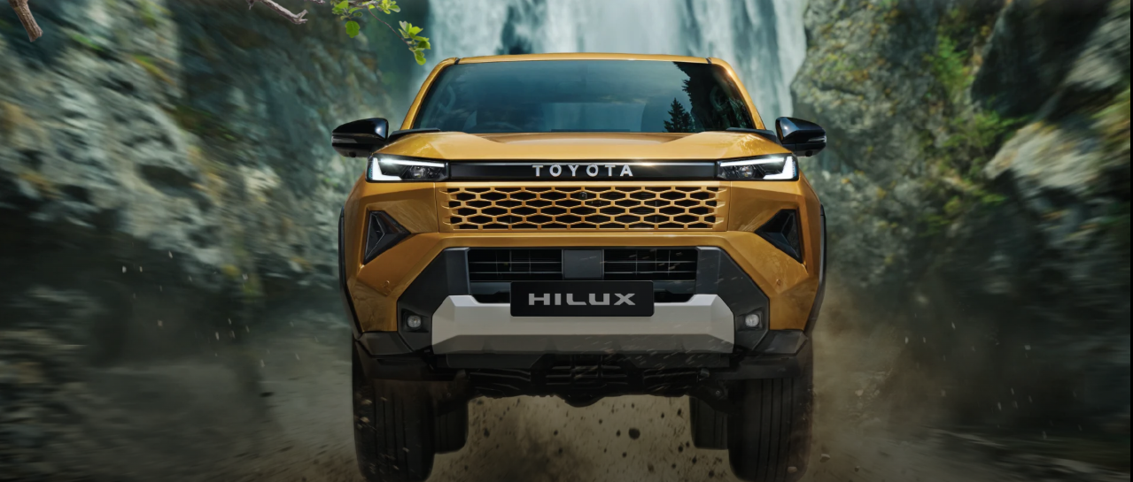

A Legacy Spanning Five Decades
Before diving into the new model, it's worth remembering that the Hilux nameplate is not new to the world. Toyota's brochure proudly traces the truck's lineage back to 1968, with major generational updates arriving roughly every five to seven years — 1972, 1978, 1983, 1988, 1997, 2004, 2015, and now 2026. Globally, the Hilux has earned a reputation as one of the most dependable trucks ever built, having survived deserts, war zones, and some of the harshest terrains on the planet. Toyota's tagline for this legacy sums it up nicely: five decades, countless terrains, one reputation. The 2026 model brings that same never-say-die character to Indian roads, but with sharper styling and a lot more onboard technology than any of its ancestors.

Design & Styling: The "Cyber Sumo" Look
The most talked-about aspect of the new Hilux is undoubtedly its design. Toyota describes the front-end architecture as being inspired by the stance of a sumo wrestler — a strong, always-ready posture translated into what the brand calls "assertive arms," a "strong core," and a "stable base." The result is a dual-volume front fascia with a chunky honeycomb grille, sharp LED headlamps with integrated daytime running lights, and a bumper design that looks like it means business.
Elsewhere, the exterior gets hexagonal grip side steps with a honeycomb-pattern tread for safer cabin access, a tailgate assist system for effortless opening and closing of the tailgate, an integrated rear bed step for easier access to the cargo bed, and a commanding rear presence with bold TOYOTA lettering across the tailgate. Higher trims also get a sharkfin antenna, LED tail lamps, and stylish alloy wheels finished in a matte-black multi-spoke design that suits the truck's rugged persona.
One genuinely useful engineering detail buried in the brochure is the Hilux's water wading capacity of up to 700 mm (27.5 inches) — a figure that will matter a great deal to buyers who regularly cross flooded roads or shallow river crossings during monsoon season.
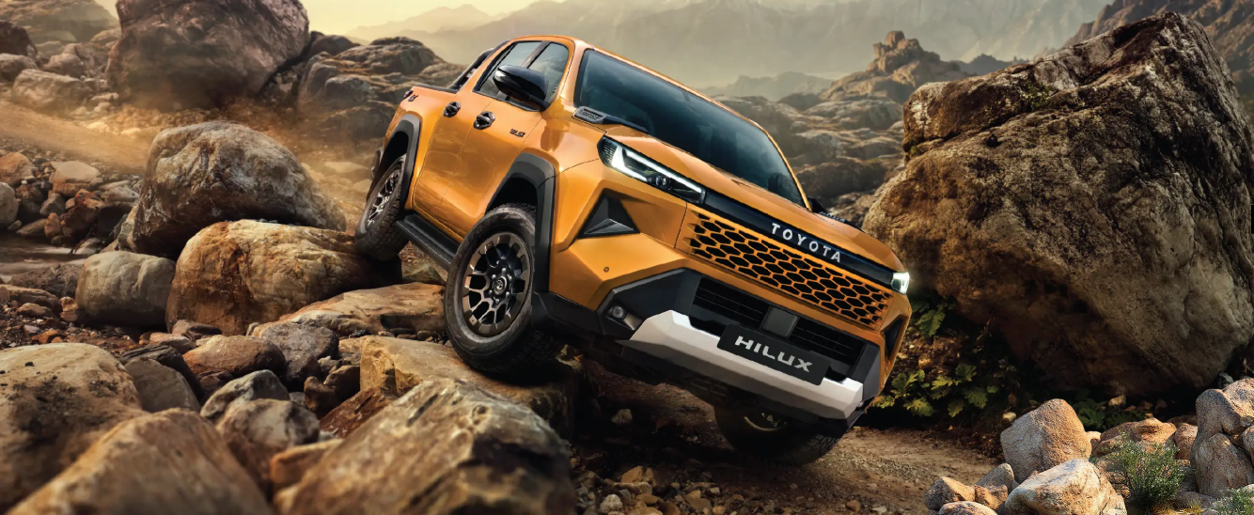

Interior: Robust Simplicity Meets Modern Tech
Step inside, and the new Hilux trades some of its exterior aggression for what Toyota calls "robust simplicity." The cabin is finished in an all-black theme with soft-touch upholstery and metallic accents, giving it a more premium feel than older-generation Hilux models. The centrepiece is a large 12.3-inch premium multimedia display (an 8-inch unit is offered on the base GX variant), paired with a 7-inch TFT combination meter that displays essential driving information clearly.
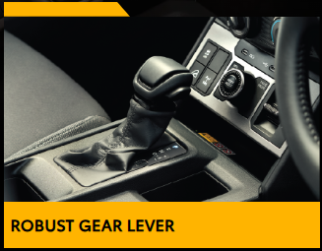
Practical touches abound: a robust gear lever with a solid, mechanical feel; steering-mounted audio, MID, telephone, and voice recognition switches; an available 8-speaker audio system; wireless Android Auto and Apple CarPlay (standard on the top VX trim); and a wireless smartphone charger for keeping devices topped up on the move. The second row gets a 60:40 split, tip-up bench for extra cargo flexibility, while smart entry with push-button start makes daily use noticeably more convenient on the range-topping variant.
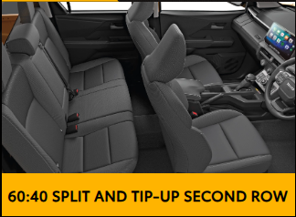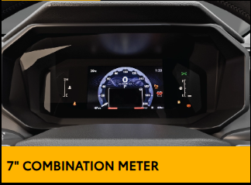
Other small but appreciated details include a rear centre armrest with cupholders, an upper glovebox with a retractable lid, large cup holders throughout the cabin, and a soft-touch centre console. It is clear Toyota wants the new Hilux to feel just as at home on a daily commute as it does on a dirt trail.
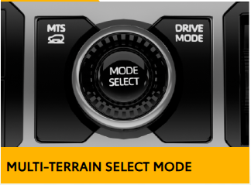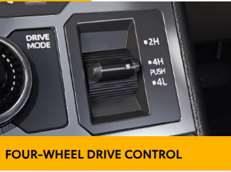

Engine & Performance: 500 Nm, Zero Hesitation
Under the hood sits a 2.8-litre BS6 Phase 2 diesel engine producing 150 kW of power and a hefty 500 Nm of torque, paired exclusively with a 6-speed automatic transmission. Toyota's own marketing line for this powertrain, "500 Nm. Zero hesitation," is a fair summary of what buyers can expect — strong low-end pulling power for towing and off-roading, along with the ability to cruise comfortably at highway speeds. An 80-litre fuel tank means fewer stops on long road trips, which matters for a truck aimed at long-distance adventure and touring use.
The Hilux is offered with both 2WD and 4WD drivetrain options, which Toyota says lets buyers pick the balance of efficiency, traction, and capability that suits their driving style. Suspension duties are handled by a double wishbone setup at the front and a leaf-spring rigid axle at the rear — a tried-and-tested configuration for load-carrying pickups that also holds up well to rough-road articulation. Braking comes from ventilated discs up front and drums at the rear, running on 265/65 R17 alloy wheels with a matching steel spare.
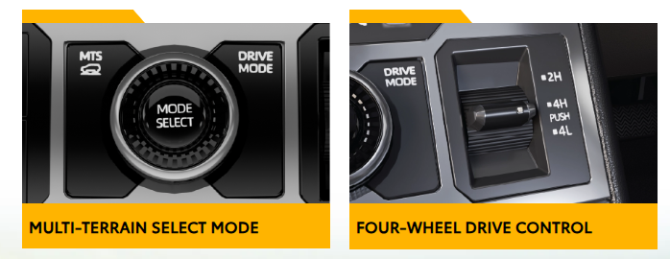

4x4 Capability: Built to Go Beyond the Map
For serious off-road enthusiasts, the new Hilux packs a genuinely comprehensive off-road toolkit. This includes 4WD with High (H4) and Low (L4) range, Electronic Drive Control, an Electronic Differential Lock, Traction Control, Downhill Assist Control, and a Multi-Terrain Select mode that lets the driver tailor the drivetrain's behaviour to snow, sand, mud, or rocky terrain.
An Auto Limited Slip Differential (Auto LSD) helps maintain mobility when wheel slip occurs, even in 2WD mode, while an Advanced 4WD System and Rear Differential Lock (Diff-Lock) work together to deliver confidence across a wide range of terrains. Toyota has also reinforced the truck's underpinnings with enhanced body rigidity, additional body mounting points for improved stability and ride comfort, and hydraulic engine mounts with shear-type body mounts designed to minimise cabin vibrations for a more refined ride, even off the beaten path. The easy-access four-wheel-drive dial in the centre console — with clearly marked 2H, 4H, and 4L settings — makes switching between modes simple, even for first-time 4x4 owners.

Safety: Built Tough, Backed by Real Protection
Safety has clearly been a priority for the new Hilux. The truck comes with 7 SRS airbags as standard across the range, along with ABS with Emergency Brake Signal, Vehicle Stability Control (VSC) with Brake Assist, and an Impact Absorbing Structure built around Toyota's GOA (Global Outstanding Assessment) body construction philosophy.
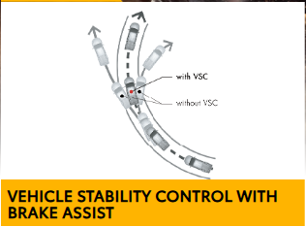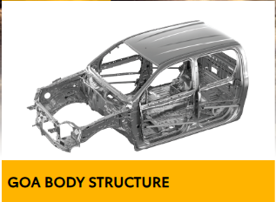
Additional safety equipment includes a Tyre Pressure Monitoring System (direct type, available on the VX trim), 3-point ELR seatbelts for all seating positions, a seatbelt reminder, height-adjustable front seatbelts, a child restraint system with ISOFIX and tether anchors on the second row, an emergency braking signal, an impact-sensing auto door unlock, and a speed-sensing door lock. The range-topping VX variant adds a Panoramic View Monitor for a bird's-eye view while parking or manoeuvring in tight spaces, along with a rear camera as standard fitment across the range. An anti-theft alarm rounds out the package for peace of mind when the truck is parked.

Connected Car Technology: Toyota Connect
The new Hilux also comes equipped with Toyota Connect, the brand's suite of connected car features designed to keep owners in command of their vehicle wherever the journey leads. Through the companion smartphone app, owners get access to remote commands, theft alert and stolen vehicle locator functionality, live tracking and vehicle status updates, and detailed driving insights along with trip information. For a lifestyle vehicle that is likely to spend time in remote locations, having live location tracking and theft alerts adds a genuine layer of reassurance.

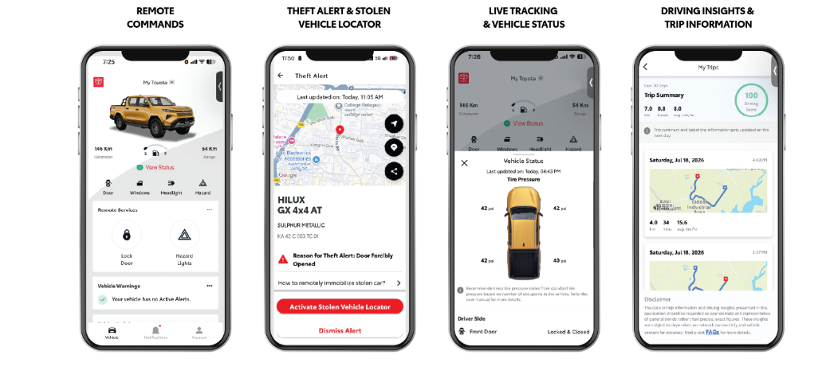

Variants Explained: GX 4x2 AT, GX 4x4 AT & VX 4x4 AT
Toyota is offering the new Hilux in India across three distinct variants, allowing buyers to choose the right balance of price, drivetrain, and features for their needs:
- GX 4x2 AT — the entry point into the Hilux range, offered with rear-wheel drive and the 6-speed automatic transmission. It gets the core safety kit (7 airbags, ABS with EBD, VSC) along with a more basic feature set, including an 8-inch infotainment screen, manual air conditioning, and a manual key with a foldable design.
- GX 4x4 AT — essentially the same feature set as the GX 4x2, but adds proper four-wheel-drive capability with 4WD High and Low range, Multi-Terrain Select, Electronic Drive Control, and Electronic Differential Lock, making it the value pick for buyers who need genuine off-road ability without paying for the top-spec luxuries.
- VX 4x4 AT — the flagship trim, adding the 12.3-inch infotainment display, 8-speaker audio, wireless Android Auto/Apple CarPlay, wireless charger, smart entry with push-button start, TPMS, a Panoramic View Monitor, retractable upper glovebox lid, and exclusive colour options such as Sulphur Metallic and Attitude Black.
This tiered approach means buyers who primarily want the Hilux for its looks and comfort can opt for the GX 4x2, while serious off-road users and those who want the fullest possible feature list will likely gravitate towards the VX 4x4 AT.
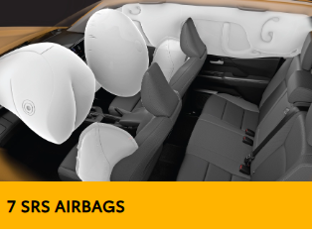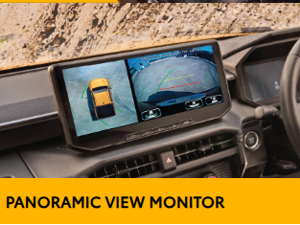

New Toyota Hilux Price in India
According to the latest information, the new Toyota Hilux is priced from ₹31.99 lakh to ₹36.69 lakh (ex-showroom) across its three variants. This positions it as a premium offering in the lifestyle pickup segment, reflecting its extensive feature list, strong powertrain, and Toyota's reputation for long-term reliability. As with any new launch, it's worth checking with your nearest Toyota dealership for the latest on-road price in your city, since state-level taxes and registration costs can meaningfully change the final number.

Colour Options: Pick Your Shade of Adventure
Toyota is offering the new Hilux in six colour options, letting buyers pick a shade that matches their personality as much as their terrain of choice:
- Sulphur Metallic (VX grade only)
- Ash
- Super White
- Platinum Pearl White Metallic
- Emotional Red
- Attitude Black (VX grade only)
The bold Sulphur Metallic shade seen prominently in Toyota's marketing material is easily the most eye-catching of the lot, though buyers who prefer a more understated look will likely gravitate toward Ash or Super White.

Genuine Accessories: Make It Yours
Toyota has also rolled out a dedicated accessories brochure for the new Hilux, reinforcing the truck's "adventure-ready" positioning. On the exterior, buyers can add a front bumper garnish, hood garnish, fuel lid garnish, wheel house liner set, side P mould, side visor with chrome, over-fenders, a rear lamp garnish, a headlamp garnish, and even a front bumper hole set for a more aggressive look.
Inside the cabin, a 3D floor mat set is available to protect against mud and moisture, and on the electrical side, buyers can opt for a welcome door lamp that projects the Hilux logo onto the ground when a door is opened, along with an illuminated scuff plate for a touch of ambient style. Genuine Toyota accessories also come backed by a 1-year warranty, giving buyers confidence that these add-ons meet the same quality bar as the vehicle itself. As Toyota notes in its brochure, some accessories cannot be installed together, so it's best to consult your dealership before finalising an accessory list.
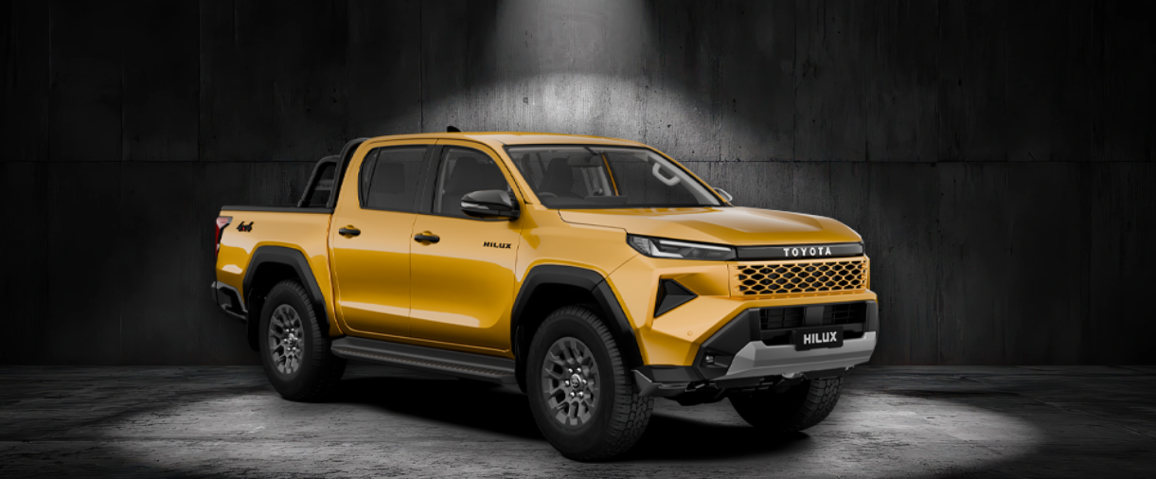

Ownership Experience & After-Sales Network
Buying a lifestyle pickup is only half the equation — after-sales support matters just as much, especially for a vehicle that may be driven to remote locations. Toyota backs the new Hilux with an unmatched warranty of 3 years or 100,000 km, along with access to Toyota Trust (for buying, selling, and exchanging used cars), Toyota Financial Services, and the Toyota Mobility Service for fleet and leasing needs.
Toyota's ownership ecosystem also includes its T-Care suite of services — TDeliver, TAssist, TSecure, TSmile, TGloss, TInspect, TSparsh, TServ, TSaath, TChoice, TClub, and TShield — covering everything from doorstep delivery and roadside assistance to used-car inspections and loyalty benefits. Backing all of this is a service network spanning more than 900 cities across India, with over 1,400 total touchpoints, making it easier for Hilux owners to find support wherever their journeys take them.

Full Specifications: New Toyota Hilux
Here is a consolidated look at the core specifications of the new Toyota Hilux, as listed across its three variants.
Specification | GX 4x2 AT | GX 4x4 AT | VX 4x4 AT
Engine | 2.8 L Diesel | 2.8 L Diesel | 2.8 L Diesel
Transmission | 6-Speed Automatic | 6-Speed Automatic | 6-Speed Automatic
Drive Type | 4x2 | 4x4 | 4x4
Max. Power | 150 kW | 150 kW | 150 kW
Max. Torque | 500 Nm | 500 Nm | 500 Nm
Fuel Tank | 80 L | 80 L | 80 L
Overall Dimensions (L x W x H) | 5320 x 1855 x 1815 mm | 5320 x 1855 x 1815 mm | 5320 x 1855 x 1815 mm
Wheelbase | 3085 mm | 3085 mm | 3085 mm
Min. Turning Radius | 6.3 m | 6.3 m | 6.3 m
Front Suspension | Double Wishbone | Double Wishbone | Double Wishbone
Rear Suspension | Leaf Spring Rigid Axle | Leaf Spring Rigid Axle | Leaf Spring Rigid Axle
Front Brakes | Ventilated Discs | Ventilated Discs | Ventilated Discs
Rear Brakes | Drum | Drum | Drum
Tyres | 265/65 R17 Alloy | 265/65 R17 Alloy | 265/65 R17 Alloy
Infotainment Screen | 8 inches | 8 inches | 12.3 inches
Speakers | 4 | 4 | 8
Airbags | 7 SRS | 7 SRS | 7 SRS
Panoramic View Monitor | No | No | Yes

Variant Comparison: Which Toyota Hilux Should You Buy?
If you're trying to decide between the three variants, here is a simplified comparison of the key features that differ across the Hilux line-up, brought to you by BikeCarHub to make your buying decision easier.
Feature | GX 4x2 AT | GX 4x4 AT | VX 4x4 AT
4WD High/Low Range | No | Yes | Yes
Electronic Differential Lock | No | Yes | Yes
Multi-Terrain Select | No | Yes | Yes
Wireless Android Auto/Apple CarPlay | No (Wired) | No (Wired) | Yes
Wireless Charger | No | No | Yes
Smart Entry & Push Start | No | No | Yes
TPMS (Direct) | No | No | Yes
Cruise Control | No | No | Yes
Exclusive Colours (Sulphur Metallic/Attitude Black) | No | No | Yes
In short: pick the GX 4x2 AT if you mainly want the Hilux for its road presence and comfort, step up to the GX 4x4 AT if genuine off-road capability matters to you but you don't need the top-tier tech, and go for the VX 4x4 AT if you want the complete, no-compromise Hilux experience.

Toyota Hilux vs Its Own Legacy: What's New in 2026?
Long-time Toyota fans will notice that the 2026 Hilux takes a sharper design turn than any generation before it. Where earlier Hilux models leaned on a more conventional pickup silhouette, the new model's Cyber Sumo-inspired face, honeycomb grille, and dual-volume architecture give it a much more distinctive road presence. Inside, the jump to a 12.3-inch touchscreen, wireless smartphone connectivity, and a fully digital-feeling cockpit brings the Hilux's cabin experience much closer to what buyers now expect from premium SUVs, rather than a purely utilitarian truck interior.
Mechanically, the core 2.8-litre diesel and 6-speed automatic combination carries forward Toyota's proven reliability, but the addition of features like Auto LSD, Downhill Assist Control, and Multi-Terrain Select shows Toyota is keen to keep the Hilux competitive against newer rivals in the lifestyle pickup space, rather than resting on its reputation alone.
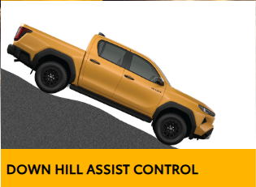

Who Should Buy the New Toyota Hilux?
The new Hilux is best suited to buyers who genuinely need — or want — a vehicle capable of serious off-road duty without sacrificing daily comfort. This includes weekend adventurers who tow trailers or ATVs, buyers in hilly or flood-prone regions who value the 700 mm wading depth and 4WD Low range, and fleet or commercial buyers drawn to Toyota's legendary reliability and extensive service network.
On the other hand, buyers looking purely for a city runabout, or those on a tighter budget, may find the Hilux's price tag and size more than what they need. For that segment, a compact SUV or a lower-priced pickup might be a more sensible fit. But for anyone who wants a genuine, go-anywhere lifestyle truck backed by Toyota's after-sales muscle, the new Hilux is shaping up to be one of the most compelling options in its class.

Final Verdict
The new Toyota Hilux arrives in India as a far more premium, tech-loaded, and design-forward truck than its predecessors, while still holding onto the core traits that made the nameplate famous worldwide: toughness, reliability, and genuine off-road capability. With a strong 2.8-litre diesel engine, a comprehensive 4x4 toolkit, a well-equipped cabin, and Toyota's dependable after-sales network backing it up, the Hilux looks set to be a serious contender for anyone shopping in the lifestyle pickup segment in India. At BikeCarHub, we'll be keeping a close eye on real-world reviews, ownership feedback, and on-road pricing as the Hilux reaches Toyota showrooms across the country.

Frequently Asked Questions
1. What is the price of the new Toyota Hilux in India?
The new Toyota Hilux is priced from ₹31.99 lakh to ₹36.69 lakh (ex-showroom), depending on the variant chosen.
2. What engine does the new Toyota Hilux use?
It uses a 2.8-litre BS6 Phase 2 diesel engine producing 150 kW of power and 500 Nm of torque, paired with a 6-speed automatic transmission.
3. Is the new Toyota Hilux available with 4x4 drive?
Yes. The Hilux is offered in both 2WD (GX 4x2 AT) and 4WD (GX 4x4 AT and VX 4x4 AT) configurations, with the 4x4 variants getting High and Low range, Electronic Differential Lock, and Multi-Terrain Select.
4. How many variants of the Toyota Hilux are available?
The Hilux is offered in three variants: GX 4x2 AT, GX 4x4 AT, and VX 4x4 AT.
5. What is the water wading capacity of the new Hilux?
The new Toyota Hilux has a water wading capacity of up to 700 mm (27.5 inches), making it well suited for flooded roads and shallow river crossings.
6. How many airbags does the Toyota Hilux come with?
The Hilux comes equipped with 7 SRS airbags as standard across all three variants, along with ABS, EBD, and Vehicle Stability Control.
7. What is the warranty offered on the new Toyota Hilux?
Toyota offers an unmatched warranty of 3 years or 100,000 km on the new Hilux, along with genuine accessories backed by a separate 1-year warranty.
8. What colours are available on the new Toyota Hilux?
The Hilux is available in six colours: Sulphur Metallic, Ash, Super White, Platinum Pearl White Metallic, Emotional Red, and Attitude Black. Sulphur Metallic and Attitude Black are exclusive to the VX variant.
9. Does the Toyota Hilux get connected car technology?
Yes, the Hilux comes with Toyota Connect, offering remote commands, theft alert and stolen vehicle locator, live tracking and vehicle status, and driving insights along with trip information.
10. What is the fuel tank capacity and infotainment screen size of the new Hilux?
The Hilux has an 80-litre fuel tank across all variants. The GX variants get an 8-inch infotainment screen, while the top-spec VX variant gets a larger 12.3-inch premium multimedia display.

SEO Details
Title Tag: New Toyota Hilux 2026: Price, Specs & Features
Meta Description: New Toyota Hilux price starts at ₹31.99 lakh. Explore full specs, features, variants, colours, and off-road capability in this detailed BikeCarHub review.
Suggested SEO Keywords: New Toyota Hilux, Toyota Hilux 2026 price, Toyota Hilux India, Toyota Hilux specifications, Toyota Hilux variants, Toyota Hilux 4x4, Toyota Hilux mileage, Toyota Hilux features, Toyota Hilux colours, Toyota Hilux review, Toyota Hilux on-road price, BikeCarHub Toyota Hilux

